Field Management of Rocky Mountain Russet (CO05068-1RU): Nitrogen and Plant Population

Samuel YC Essah
Associate Professor of Agronomy and Horticulture, and Extension Specialist
Colorado State University, San Luis Valley Research Center

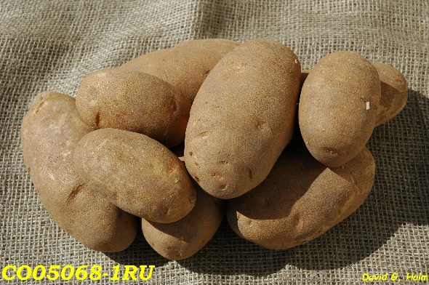
Nitrogen Fertilizer Management

Rocky Mountain Russet (CO05068-1RU) is a medium to late Russet cultivar, and a heavy nitrogen feeder. A two years study conducted indicated that a total of 223 lbs per acre of available nitrogen (N) (soil residual N + irrigation water N + applied N) was needed to produce maximum tuber yield and quality. To know how much nitrogen fertilizer to apply during the growing season, subtract residual soil and water N from the recommended total available N. Urea Ammonium Nitrate (32-0-0) was used as source of N fertilizer in this study. With 223 lb available N rate per acre, one can harvest a total of 485 cwt/acre of tubers with 90% US #1s. Premium size (> 6 oz.) tuber yield was 364 cwt/acre. No external or internal tuber defects were observed in this cultivar. Tuber specific gravity ranged from 1.096 - 1.097.
Timing of nitrogen fertilizer application is very important for maximum tuber production of Rocky Mountain Russet. To achieve maximum tuber yield, about 42% of the required seasonal nitrogen fertilizer should be applied either preplant or at planting. The remaining required seasonal nitrogen should be applied in split applications soon after tuber formation. Nitrogen fertilizer application should be completed early in the growing season to allow for tuber growth and maturity. In the San Luis Valley, nitrogen fertilizer application should be completed by July 30.

Plant Population Management
In a two years study with row spacing of 34 inches, planting seed potatoes at in-row spacing of 14 inches produced maximum tuber yield and quality. With the recommended 14 inches in-row seed spacing, the cultivar Rocky Mountain Russet produced 444 and 420 cwt/acre of total and marketable tuber yields, respectively, with 95% US #1s. With this in-row seed spacing, tuber specific gravity was observed to be 1.102, and tubers had less than 1% external or internal defects.

